Use-Case Specification: View Wiki

Revision History

|  |  |  |  |
| --- | --- | --- | --- |
| **Date** | **Version** | **Description** | **Author** |
| 21/11/2015 | 1.0 | Erste Version | Mehmet Ali Incekara |
|  |  |  |  |
|  |  |  |  |
|  |  |  |  |
|  |  |  |  |
|  |  |  |  |

Table of Contents

1. Use-Case View Wiki 4

1.1 Brief Description 4

2. Flow of Events 5

2.1 Basic Flow 5

2.2 Alternative Flows 6

2.2.1 Open wiki in the menu 6

3. Special Requirements 6

4. Preconditions 6

5. Postconditions 6

6. Extension Points 6

Use-Case Specification: View Wiki

# Use-Case View Wiki

## Brief Description

The Use-Case “View Wiki” allows the user to read information of all playable characters. The information is limited but they involve a picture, name, nickname and a short description. The user can scroll down or can search a character.

Also this view has a button to add new characters to the game/database   
(UseCase Add Character – tbd. /4. Semester)

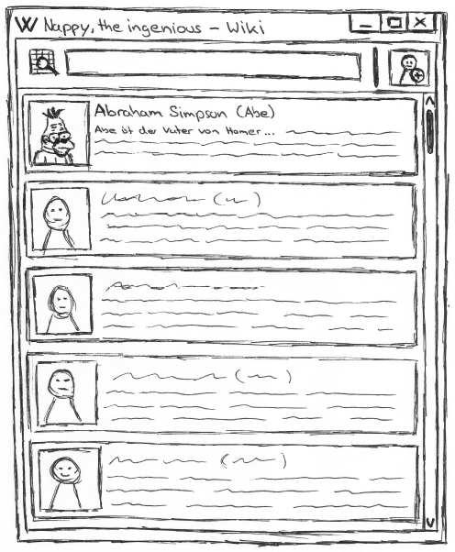

# Flow of Events

## Basic Flow

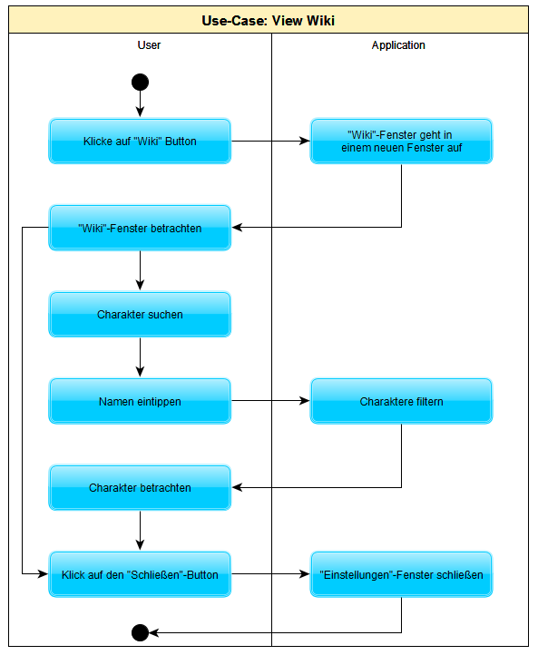

Cucumber is not supported for desktop applications. We are using SikuliX 1.1.0 for our user tests.

## Alternative Flows

### Open wiki in the menu

The user can use the button “Wiki” in the menu “Hilfe”.

# Special Requirements

(n/a)

# Preconditions

(n/a)

# Postconditions

(n/a)

# Extension Points

(n/a)